Note: This template is for PCEM for materials reductions or recirculation.
Cover page : Free design, corporate logos can be used (recommended). The content presented here is mandatory, but the format can be changed.
See general filling instructions on Page 3.
When the sections are completed, change the pink font colour to black.
Delete this box.
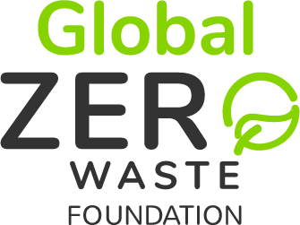
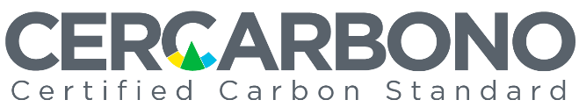

Monitoring Report

-PCEM Name-

Space for corporate logos

Document issued by: | Name(s) of the proponent(s) of the programme or project.
Date of issuance: | Day.month.year this report was issued.
Monitoring period: | Day.month.year to day.month.year.
Contact: | Physical address.  E-mail address.  Telephone number(s).  Web site.

Content

Abbreviations and acronyms 4
1 General information about the PCEM 5
1.1 Information on the PCEM holder 5
1.2 Information from other institutional participants in the PCEM 5
1.3 PCEM description 6
1.4 Status of implementation of the PCEM 6
1.5 Spatial and temporal limits of the PCEM 6
1.5.1 Spatial limits 6
1.5.2 Time limits 6
2 Status of the Circular Economy Programme of Activities 7
2.1 Coordinating entity 7
3 Deviations in the implementation of the PCEM 8
4 Methodological deviations 9
5 Quantification of materials reduction or recirculation 10
5.1 Leakage 10
5.2 Reassessment of the baseline scenario 10
5.3 Natural disturbances and other catastrophic events 10
6 PCEM Monitoring 11
6.1 Execution of the monitoring plan 11
6.2 Information management 11
6.3 Expost parameters 11
7 Legal and documentary aspects 12
7.1 Legal requirements 12
7.2 PCEM documentation 12
8 Stakeholder consultation 13
9 Contributions to the Sustainable Development Goals of the United Nations 14
10 References 15
11 Document history (MR) 16
12 Template history 17

Instructions for filling out this document

This Monitoring Report (MR) template is designed for Programmes or Projects on Circular Economy Materials (PCEM) that wish to verify their project and issue Circular Economy Credits (CECs) under the Voluntary Programme on Circular Economy (VPCE).
When filling this document:
- Delete this page.
- Delete the instructions given in each section and all text in this colour.
- If for some reason a section or subsection does not apply, do not delete it but indicate that it does not apply.
- Once you have added all the necessary content, generate the table of contents of this document again (right click somewhere in the table of contents, in the pop-up menu select “Update fields” and finally choose “Update entire table”).
The MR must be delivered in Acrobat (.pdf) format. In Microsoft Word, when generating the document in this format (Save as, .pdf format), activate the option “Create bookmarks using: Headings”.
Doing it this way will facilitate the work and reduce the VVB’s and certifier's management time.
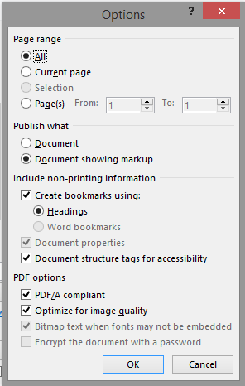

Abbreviations and acronyms
Enter in alphabetical order the acronyms and abbreviations used in the MR.
CEC | Circular Economy Credit
MR | Monitoring Report
PCEM | Programme or Project on Circular Economy Materials
PDD | Project Description Document
VPCE | Voluntary Programme on Circular Economy
VVB | Validation and Verification Body

- General information about the PCEM
  - Information on the PCEM holder
Provide information about the individual or legal entity that holds a legal document of representation, issued, or endorsed by the PCEM holder or by individuals or organisations that grant certain rights with respect to the PCEM, including the withdrawal of the Circular Economy Credits certificate.
In both cases, legal evidence of representation must be attached.
Name of the institution (if applicable):
Roles or responsibilities:
ID:
Location:
Phone number:
E-mail address:

  - Information from other institutional participants in the PCEM
Provide information on people or organisations relevant to the PCEM. Duplicate this table if necessary, using one for each participant.
Name of the institution (if applicable):
Roles or responsibilities:
ID:
Location:
Phone number:
E-mail address:

  - PCEM description
Provide a brief description (between 300 and 500 words) of the implemented programme or project activity, including the duration or lifetime of the PCEM, the location, the areas, facilities, or processes that compose it. In case this is a Programme of Activities or a Grouped Project, indicate it in this section.

  - Status of implementation of the PCEM
Provide a brief description of the implementation status of the PCEM, including the following:
- Current phase of implementation.
- Net material reductions or recirculation achieved in this monitoring period.
- If the PCEM has been previously verified, detail how many verification events conducted.

  - Spatial and temporal limits of the PCEM
    - Spatial limits
Report and justify any changes in any of the areas, facilities, or processes that constitute the PCEM.

    - Time limits
Indicate the time limit for monitoring the PCEM (start date: day.month.year and end date: day.month.year).
- Status of the Circular Economy Programme of Activities
If it is not a Programme of Activities, please DELETE the entirety of Section 2.
If you include this section, add the relevant acronyms at the beginning of the document.
Describe the current status of the Programme:
- Dates and names of the Circular Economy Programme Activities (CEPAs) included so far.
- Verifications conducted with their respective monitoring periods, tonnes reduced or recirculated, and the dates of issuance of the CECs.

  - Coordinating entity
Indicate the name of the Coordinating entity (CoE).

  - Implementation of the CoE management system
Describe the implementation status of:
- The review process and parameters for CEPA inclusion.
- Documentary control system for CEPA.
- Compliance with the principles of the CECs.
- Deviations in the implementation of the PCEM
Provide details on any deviations in the processes, machinery, or technologies, that occurred during the monitoring period according to the type of PCEM, with respect to what is established in the PDD.
- Methodological deviations
Specify whether there were any methodological deviations during the monitoring period and whether these were approved.
- Quantification of materials reduction or recirculation
Quantify, for the monitored period, the net reductions or recirculation of the PCEM by providing sufficient information to make it possible to reproduce the calculation. The process and results should be presented in a separate file (Excel or equivalent).
In the following table, list the net material reductions or recirculation from the PCEM.
Year | Baseline scenario | Project scenario |  | Net reductions or recirculation (tonne/year)
 | Material  (tonne/year) | Reduced or recirculated material  (tonne/year) | Material  (tonne/year)
Provide an overview of the criteria, procedures, or good practice guidelines used for the calculation of material reductions or recirculation.

  - Leakage
Submit the result of the activity data monitoring and the calculation of the total actual leakage associated with the PCEM, together with supporting documentation.

  - Reassessment of the baseline scenario
Provide information on any changes the PCEM has made that affect the baseline scenario proposed in the PDD.

  - Natural disturbances and other catastrophic events
Indicate whether natural disturbances (droughts, fires, floods, etc.) or catastrophic events (wars, vandalism, third party burnings, etc.) that affected the PCEM occurred during the monitoring period.
- PCEM Monitoring
  - Execution of the monitoring plan
Indicate whether the monitoring plan was implemented as planned. If there were any changes, describe and justify them.

  - Information management
Indicate whether the information was managed as planned. If there were any changes, describe and justify them.

  - Expost parameters
List the parameters monitored during the monitoring period and for each of them include the information requested in the methodology, containing at least, but not limited to:
- Type(s) of data and information, including units of measurement.
- Values monitored.
- The origin of the data.
- Monitoring methods (including estimation, modelling, measurement, calculation, and uncertainty approaches).
- Monitoring frequency.
- Monitoring roles and responsibilities, including procedures for authorisation, approval, and documentation of changes to recorded data.
- Controls including internal checking of input, transformation, and output data, and procedures for corrective actions.
- Legal and documentary aspects
  - Legal requirements
Indicate any changes or updates to the local, regional, or national regulatory framework that apply to the PCEM.
If an environmental licence, or any other environmental legal requirement, has been requested, indicate how it has been followed up during the monitoring period and provide the corresponding evidence.

  - PCEM documentation
Describe and include supporting or evidentiary documentation demonstrating the PCEM's compliance with the Global Zero Waste and Cercarbono’s Protocol for Voluntary Certification of Circular Economy. This documentation must be consistent with the validation, verification, and certification processes.
- Stakeholder consultation
As established in the PDD, describe any additional processes of engagement or response to complaints and grievances that occurred during the monitoring period. If so, describe how the comments received were considered and how they were communicated.
- Contributions to the Sustainable Development Goals of the United Nations
Report on the contributions of the PCEM to the UN Sustainable Development Goals generated during the monitoring period, using the Tool to Report Contributions of Circular Economy Initiatives to the Sustainable Development Goals, available at www.cercarbono.com.
- References
List all the references used in the development of the Monitoring Report. All references should be available for consultation by the VVB.

- Document history (MR)
Indicate the full history of the MR, with correct and updated versions, and edit dates, and include a brief description of the changes made from the previous version.
Version | Date | Comments or modification
1.0 | Day.month.year | Initial version.

- Template history
Version | Date | Comments or modifications
1.0 | 23.06.2023 | Initial version.
(Do not delete or alter this section, delete this instruction).

For the VPCE, materials are understood as all waste materials that can be used.

